

**Standard Operating Procedures**

**Advanced Infantry**

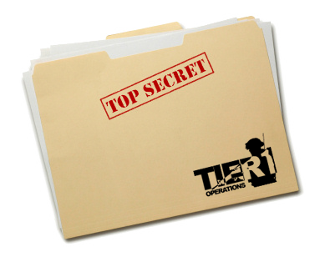

Contents

1. Advanced Infantry 3

A. Formations and Sectors 3

B. Immediate Action Drills 3

C. Buddy Team Bounding Overwatch 4

# Advanced Infantry

This section will give further information on fireteam formations, immediate action drills, buddy team bounding overwatch.

## Formations and Sectors

During advanced infantry training you will practice movement in formation with an entire fireteam. If you need a refresher on the different formations see Chapter 1 Basic Infantry.

Also pay attention to the STHUD, a very useful addon that allows you to see where your fireteam members are, their names and also where north, east, south and west is.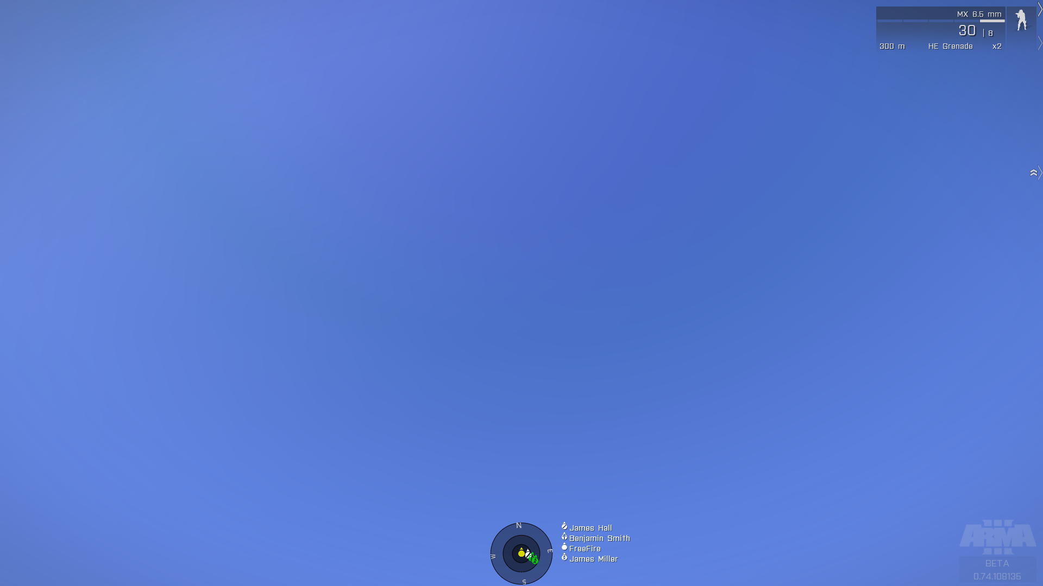

The inner circle is 10 meters, the next one 25 and the last one 50. remember to try and keep the spacing between you and your team mates at 5 meters to prevent multiple casualties due to explosives.

## Immediate Action Drills

#### Contact Drill (Immediate Assault Drill)

When to use the contact drill:   
Enemies are nearby and pose an immediate threat to you or friendlies. This drill is also used when your team comes under fire.

How to do the contact drill:  
When you spot the immediate threat you start with the key word: **'Contact'** followed by a direction **'Front, Front-Right, Right, etc.'**. The fireteam will then face in that direction and start suppressing that area, whether they can see a target or not. The fireteam leader will send a contact report over the radio to the rest of the squad as soon as possible. Once the threat is dealt with, all fireteam members should cover their sectors again.

#### Freeze Drill (Immediate Halt Drill)

When to use the freeze drill:  
You have spotted a (possible) threat that is not an immediate threat to you or friendlies and requires further investigation.

How to do the freeze drill:  
When you spot the threat, call out **'Freeze'** on the radio.And then continue over direct chat with the **'Type of threat', 'direction'** and **'range'** (these do not need to be very accurate). The entire team will hold and face their sectors. Except for the fireteam leader, he will try to find the threat and then report it accurately to the squad leader with **'Unit that is reporting the threat'** **'Type of threat', 'compass direction'** and **'range'.**

## Buddy Team Bounding Overwatch

Bounding overwatch is a movement technique that allows a fireteam to constantly keep half of its members suppressing the target and the other half moving. It can be used both to advance towards an enemy position or to fall back. It can also be useful to cross large dangerous areas.

Bounding is done in buddy teams (red and blue), see Chapter 1: Basic Infantry for more info about the buddy teams. The team leader will announce **'Bounding Overwatch', 'destination or direction' 'Team that moves first'**. For example: 'Bounding Overwatch, to the large hangar to the north, Blue bound/move'.

The first team (here blue) will then move up 15 meters and hold (if possible in cover), start suppressing the enemy and call over direct chat **'Blue Set'** the other ream (red) will then move up and pass the first team calling out **'Passing left/right'**, they will then hold 15 meters in front of the first team, start suppressing and announce **'Red Set'**. Blue team will then move again, etc. until the target is reached. The teamleader will then announce 'Regroup' to end the Bounding Overwatch.

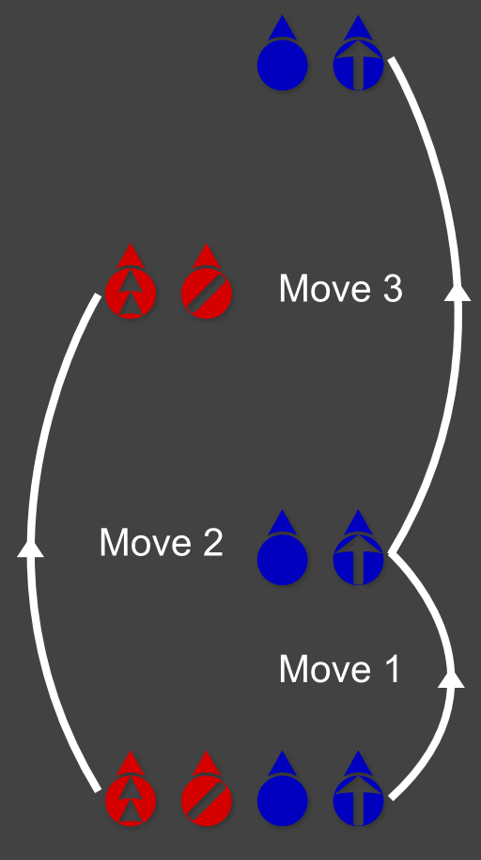Note that it is important to not move further than 15 meters, or you will not be able to hear your team mates over the sound of the gunfire.